As a general rule, an AGV robot consists of **five essential elements**: a navigation system, safety system, power system, motion system, and vehicle controller.

* **Navigation system**: this is the part of the AGV robot responsible for receiving and processing information to follow the preset route or direction and drive the vehicle. There are multiple types of navigation, including laser, wire, and magnetic, among others.
* **Safety system**: each AGV robot has safety components adapted to its functions, ensuring that movements are executed in the safest way possible. One example of a safety system would be laser scanners, which stop the vehicle when there’s an obstacle in its path.
* **Power system**: automated guided vehicle robots have a battery that provides them with the energy they require to move. Each type of AGV robot will have a different battery and charging method based on the needs of the warehouse or production center.
* **Motion system**: AGV robots integrate multiple components that enable the vehicles to move and perform tasks. This category runs the gamut from motors and wheels to the mast and the hydraulic system used by the robot to lift the load.
* **Vehicle controller**: AGV robots are guided by means of a [programmable logic controller (PLC)](https://www.mecalux.com/blog/programmable-logic-controller-plc-logistics), which articulates the information received from the software and facilitates the autonomous movement of the vehicle.

**L298N Motor Driver Voltage:**

The module has two screw terminal blocks for the motor A and B, and another screw terminal block for the Ground pin, the VCC for motor and a 5V pin which can either be an input or output.

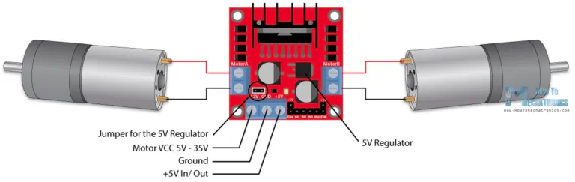

This depends on the voltage used at the motors VCC. The module have an onboard 5V regulator which is either enabled or disabled using a jumper. If the motor supply voltage is up to 12V we can enable the 5V regulator and the 5V pin can be used as output, for example for powering our Arduino board. But if the motor voltage is greater than 12V we must disconnect the jumper because those voltages will cause damage to the onboard 5V regulator. In this case the 5V pin will be used as input as we need connect it to a 5V power supply in order the IC to work properly.

We can note here that this IC makes a voltage drop of about 2V. So for example, if we use a 12V power supply, the voltage at motors terminals will be about 10V, which means that we won’t be able to get the maximum speed out of our 12V DC motor.

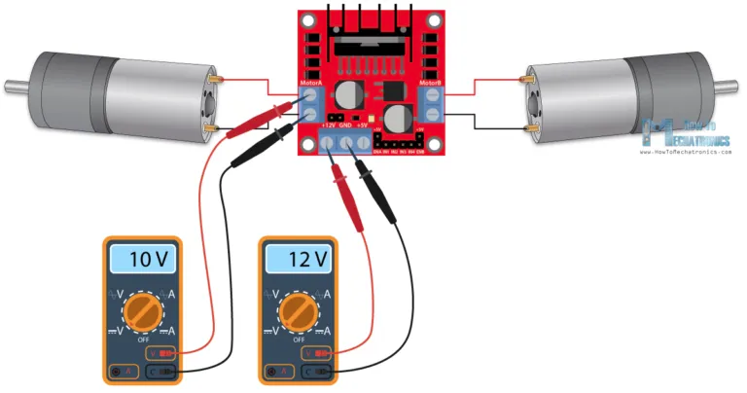

Source: <https://howtomechatronics.com/tutorials/arduino/arduino-dc-motor-control-tutorial-l298n-pwm-h-bridge/>